Exp No. -3 Create a simple cloud software application for Car Booking Reservation System using any Cloud Service Provider to demonstrate SaaS.
Done by: Juhi Surin
Register no.: 192525148

Aim:
To develop a cloud-based Car Booking Reservation System using Zoho Creator (SaaS) that enables users to book cars online and automatically calculates the total booking cost.

Procedure:
- Log in to Zoho Creator and create a new application named Car Booking Reservation System.
- Create a Car Booking Form with fields such as customer details, car model, booking type, pickup location, number of days, and cost.
- Add a workflow to calculate the Total Cost automatically based on the cost per day and number of booking days.
- Configure an On Success workflow to display a booking confirmation message after form submission.
- Enter sample booking details and submit the form to store the data in the cloud.
- Verify that the total cost is calculated correctly and the booking confirmation is displayed, demonstrating the SaaS application.

Implementation Steps:
- Open Zoho Creator and create a new application named Car Booking Reservation System.
- Design a Car Booking Form by adding all the required fields.
- Configure the field properties, including dropdowns, date, number, and currency fields.
- Create a workflow to calculate the total booking cost and display a confirmation message.
- Publish the application and test it by entering sample booking details.
- Verify that the booking information is saved successfully and the workflow executes correctly.

Output:
- Form
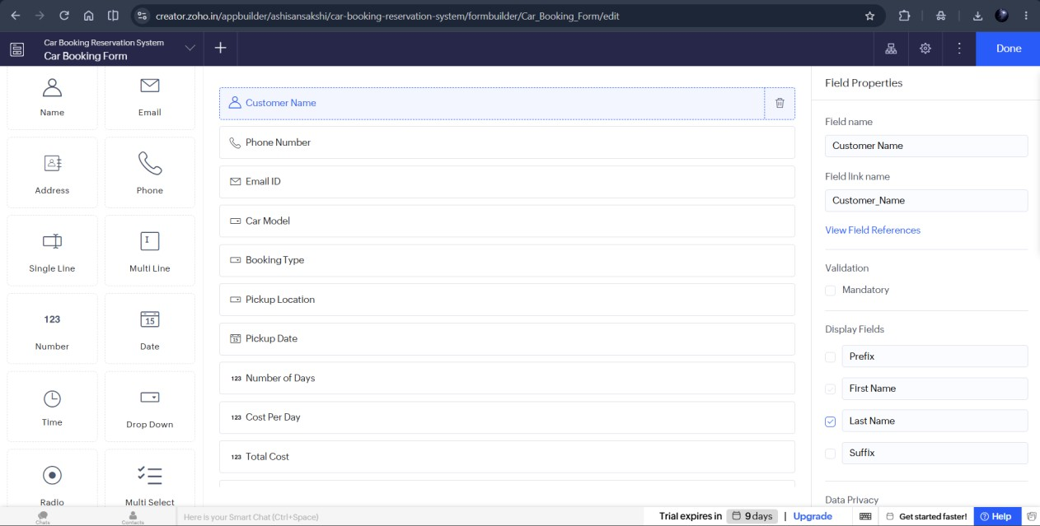

- Workflow
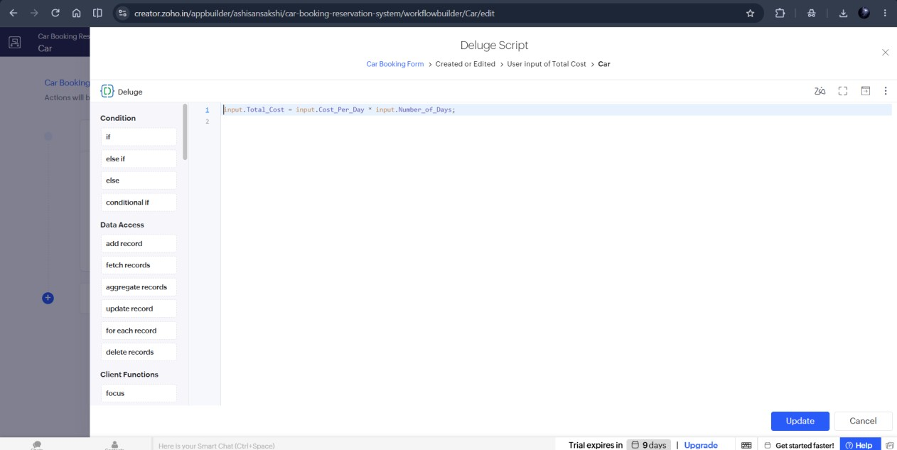

- Report
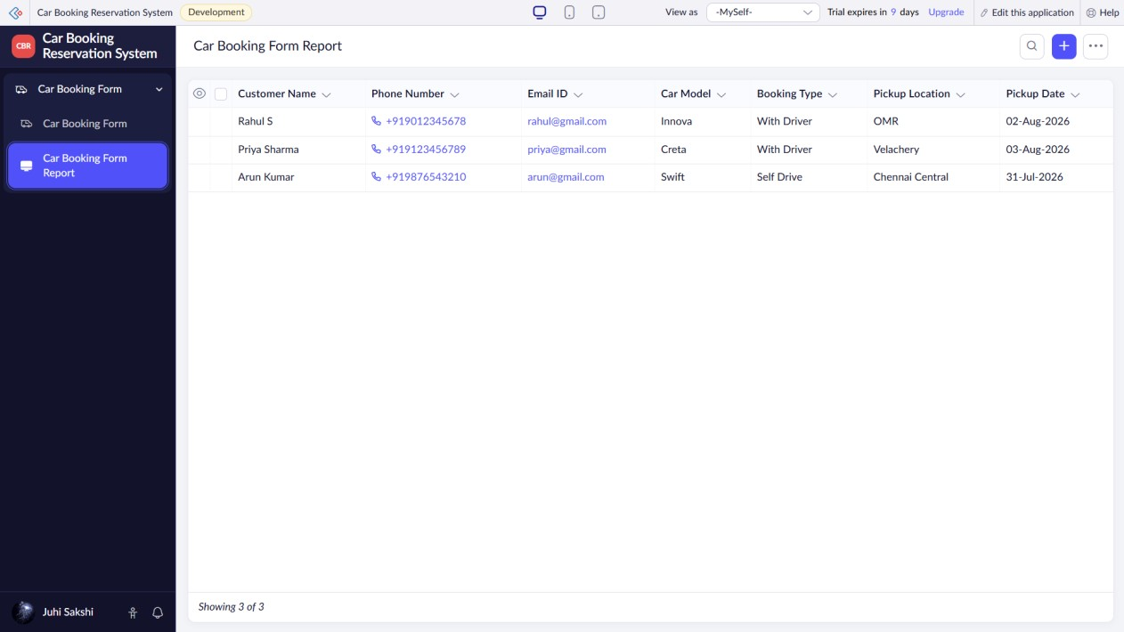

Result:
Thus, a cloud-based Car Booking Reservation System was successfully developed using Zoho Creator (SaaS), enabling users to book cars online and automatically calculate the total booking cost.

